**ORACLE ASSIGNMENT**

**Schema Objects**

A schema is defined as the core structure that represents the logical view of the entire database. Another, definition is that a Schema is an Oracle user. A schema ensures the data is well-organized and defines the relationships between the data. Using an analogy, suppose an accountant uses the human resource or financial data. The financial data can be stored under a common schema and then I can give them access to the financial data. The financial data can be stored under a common schema and the accountant can access the HR or accountant data.

Generally, the DBA does give unlimited table space to schema user but the reasons can vary. When you give unlimited table space privilege to a user, that user can create objects in any table spaces but in real life, what happens is that you create a table space for this user and the table space is the default table space for that user.

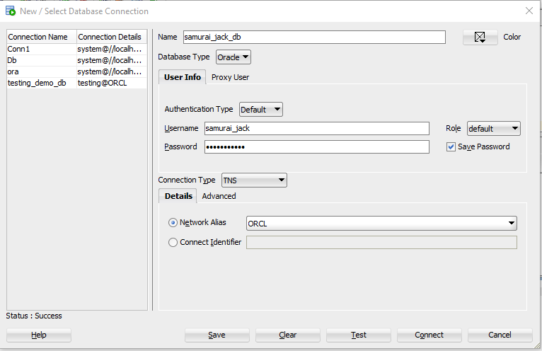

**Commands**

1. alter session set "_ORACLE_SCRIPT" = true;
2. create user samurai_jack identified by magic_sword;
3. grant connect to samurai_jack;
4. grant unlimited tablespace to samurai_jack;
5. grant create table to samurai_jack;
6. create table Individuals

(

First_Name varchar2 (50) NOT NULL,

Last_Name varchar2 (50) NOT NULL,

City varchar (50)

);

1. grant select on customers to DEMO;
2. select * from samurai_jack.customers;

**DICTIONARY VIEWS**

The Oracle database is collectively known as a data dictionary. A data dictionary contains information such as the definition of every schema object in the database including default values and tables. The amount of resources (e.g. access to tables) and their users. Since the database stores the data dictionary in tables, users can run scripts with SQL as shown below.

1. select table_name from user_tables;
2. select table_name, owner from all_tables order by owner, table_name;
3. select table_name, owner from dba_tables where owner = 'SAMURAI_JACK' order by owner, table_name;

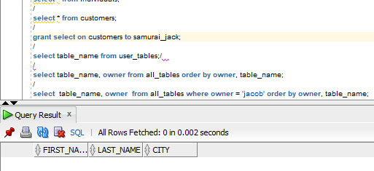

**DATA MANAGEMENT IN DIFFERENT TIME ZONES**

Different functions are used to manipulate different time things.

**Functions used**

1. Round: Used to round the nearest decimal

Format: ROUND (X, 2)

1. Sysdate: Used to show the current date of the user
2. Months_between: Used to find out the number of months between two dates

Format: select round (months_between (to_date('02-02-1995','mm-dd-yyyy'), to_date('01-01-1995','mm-dd-yyyy') ), 0) "months" from dual;

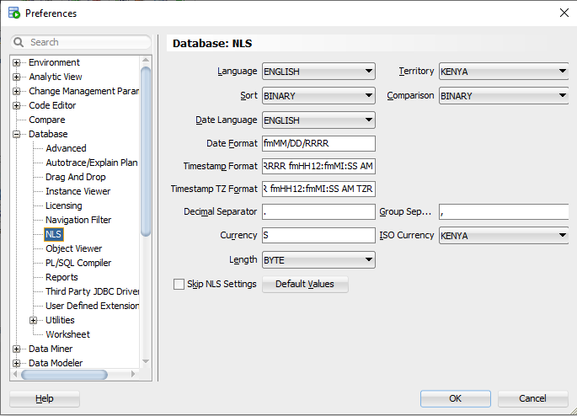

1. select sysdate from dual; /* This query provides the current date of the user's location. */
2. select sysdate + 1 from dual /* This query adds the next date to the current date */
3. select sysdate + 1/24 from dual /* One hour has been added */
4. select sysdate + 1/24/60 from dual /* Adding one minute */
5. select sysdate + 1/24/60/60 from dual /* Adding one second */
6. select months_between (to_date (' 01-01-1996 ', ' mm-dd-yyyy '), to_date (' 01-01-1995 ' , 'mm-dd-yyyy ') ) "months_between" from dual; /* Number of months between two dates */
7. select last_name "Employee_Name", round (months_between (sysdate, hire_date), 0 ) "Months_Between" from employees order by last_name desc; /* Number of months since hire_date
8. select last_name, round ( (sysdate - hire_date) / 7, 0) as weeks from employees where department_id = 90; /* The number of weeks since the person was hired at department 90 */

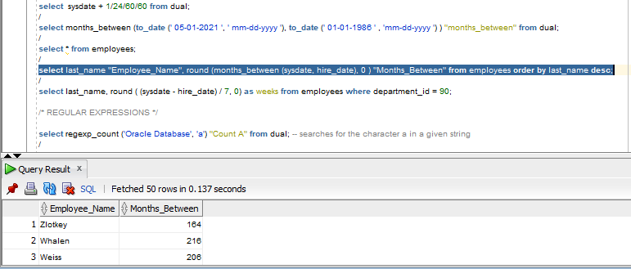

REGULAR EXPRESSIONS

They are defined as the action of counting the number of characters in a given string. A regular expression can specify complex patterns of character sequences. An example is the expression (a(b|c)d. The expression will first search for a, then either b or c and finally d. Therefore, the regular expression will match abd or acd. They are also case sensitive so caution is advised.

1. select regexp_count ('Oracle Database', 'a') from dual; -- searches for the character a in a given string

Only one character that has a will be counted which in this case is one.

1. select regexp_count ('Oracle Database', 'A', 1, 'c') from dual; --c - case sensitive

Searches the first character starting with A and moving it to C.

